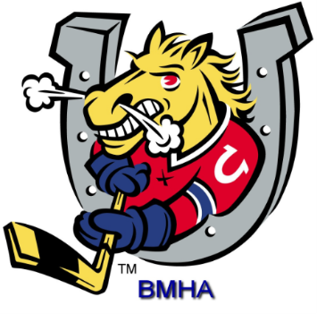

BARRIE MINOR HOCKEY ASSOCIATION

2018-2019
SPONSORSHIP

Stephanie Jones

93 Bell Farm Road, Unit 120B
Barrie, Ontario
L4M 5G1

PHONE 705-734-1121

FAX 705-734-9632

Email : bmha_admin@bellnet.ca

Mission Statement

To develop, encourage, and maximize inclusive hockey opportunities for all players and volunteers in pursuit of excellence.

Team Play Hard Work Volunteerism

Values

1. To encourage community spirit, fellowship, team play and friendly rivalries
2. To promote determination, hard work and positive life skills
3. To foster community volunteerism

History, Today, and Tomorrow

- Established 1965
- BMHA is the only league in Barrie sanctioned by Hockey Canada and insured through Hockey Canada
- Not-for-profit organization
- Coaches, Assistant Coaches, and Trainers require certification
- BMHA adheres to all Hockey Canada Rules & Regulations
- All home games are played within the Barrie area
- We have just over 2,200 skaters and over 750 volunteers within the organization
- One hundred and four House League Teams
- Twelve Select Teams
- Thirty-one Rep Teams
- Special Needs Division
- Squirt Division
- Player Development Programs

Current BMHA Initiatives

- Team donations to local charities- approximately $3,000 donated annually
- Colts Intermission Program which has Minor Tyke teams participating in scrimmages during the OHL Colts game
- Three Tournaments all located in the City of Barrie
- Bench Staff Appreciation Night to reward all bench staff for their hard work during the season with awards
- IP Festival – is a program created for Myte teams to participate in a miniature festival
- BMHA Equipment Swap- a night usually held in August where used equipment is sold for a reasonable price
- Coach Development Clinics- clinics that coaching staff can participate in to further their coaching qualifications
- Player Development Clinics hosted throughout the hockey season where players can go to develop their skating, shooting, stick handling
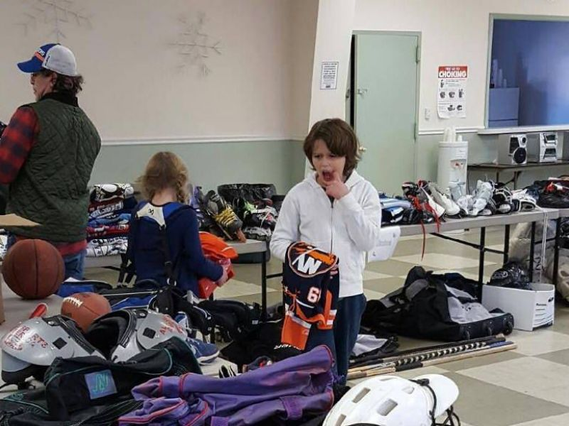
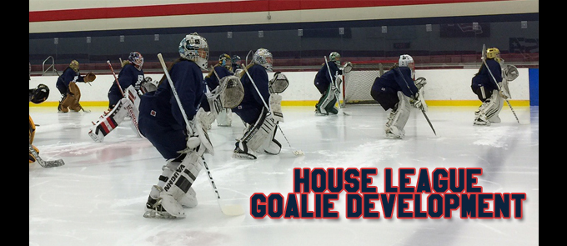

2017 Equipment Swap Player Development Programs

BARRIE MINOR HOCKEY ASSOCIATION DEVELOPMENT PROGRAM

Age | # of Teams | House League Development | Rep | Ice Allocation For House League | Ice Allocation For Rep
4 years | 8 | Myte | N/A | 20 practices  20 games | 50 practices  30 games  Additional games may occur depending on playoffs
5-6 years | 8 | Minor Tyke | N/A | 10 practices  26 games
7 years | 8 | Tyke
8 years | 8 | Novice | A, AA
9 years | 8 | Minor Atom | AE, A, AA
10 years | 8 | Atom | AE, A, AA
11 years | 10 | Minor Peewee | AE, A, AA
12 years | 10 | Peewee | MD, A-BL, A-WH, AA
13 years | 8 | Minor Bantam | MD, A-BL, A-WH, AA | 6 practices  24 games
14 years | 7 | Bantam | MD, A-BL, A-WH, AA
15 years | 6 | Minor Midget | MD, A-BL, A-WH, AA
16 or 17 years | 8 | Midget | A, AA

Why Sponsor?
The Barrie Minor Hockey Association attempts to assist each and every child ages 3 – 17 years in the City of Barrie to play hockey. We also have a Special Needs division to provide further accessibility to all Barrie children.

Your sponsorship is a very valuable piece of the fund raising budget. More importantly it gives the players on the team an identity as a TEAM. When sponsoring in the BMHA you know that your dollars are making a difference.
On behalf of all of the players, parents, and BMHA executives, thank you for your support!

In return, your partnership will offer you:
- Your company name on the back of your team’s jersey

- Your company name, logo and weblink will be featured on our BMHA website at www.barrieminorhockey.net

- Your company name, logo and weblink will be featured on the sponsored BMHA team webpage

- You will receive a sponsorship plaque with a picture of your team

- Your sponsored team will be mentioned in various media
(local radio/newspapers)

- You will be recognized for your sponsorship in any BMHA publications

- You will have the pleasure of knowing your company has made a difference to the children and youth of our community

- You are welcome to place your company literature or business cards in our “Sponsor’s Corner” at the BMHA Office

- Team sponsors are invited to promote business specials, information, promotions etc. on the BMHA website.

What cost is involved as a Team Sponsor?

Houseleague $550
Rep “AE” or MD $850
Rep “A” $950
Rep “AA” $1000
Web Sponsor $500 per month

Contact Person

Phone Number

Address

Postal Code

Sponsor Name

Email address

Website (will be linked to BMHA Website)

Payment Options
- Cheque
Payable to BMHA 93 Bell Farm Rd., Unit 120B, Barrie, Ont. L4M 5G1
- Credit Card
Visa or Mastercard

Card Number:

Expiration Date:

Thank you again for your support,
Barrie Minor Hockey Association
93 Bell Farm Road, Unit 120B Barrie, Ontario L4M 5G1
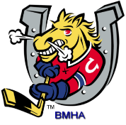
Email : bmha_admin@bellnet.ca

