2024/2025 Season

The BMHA requires all our volunteers to obtain a Vulnerable Sector Check.
Please accept this letter as a request for this service for (Position)__________________
(Name of Volunteer) ________________________________________________.
If you should have any questions, please feel free to call the office 705-734-1121
Regards,
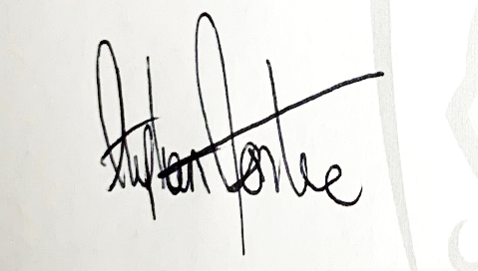
Steve Fontaine
General Manager
Barrie Minor Hockey Association

