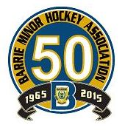
BARRIE MINOR HOCKEY ASSOCIATION

NOMINATION FORM

Meeting Date: AGM – June 15/2015

Candidate Name:

What position are you nominated for?
□ Director of Junior Rep
□ Director of Senior Rep
□ Director of HL, Myte to Atom
□ Director of Tournaments
□ York Simcoe Representative
□ President

Director Portfolio – I have served, during any of the two years immediately prior
□ as a member of a standing committee
□ as a coach, trainer, manager, assistant coach or assistant trainer

Nomination moved by: Signature:

Nomination seconded by: Signature:
Nomination Carried □ Nomination Defeated □
Chair Signature:

Must be submitted no later than: June 1/2015

