Barrie Colts Hockey Sweater Sale
$50
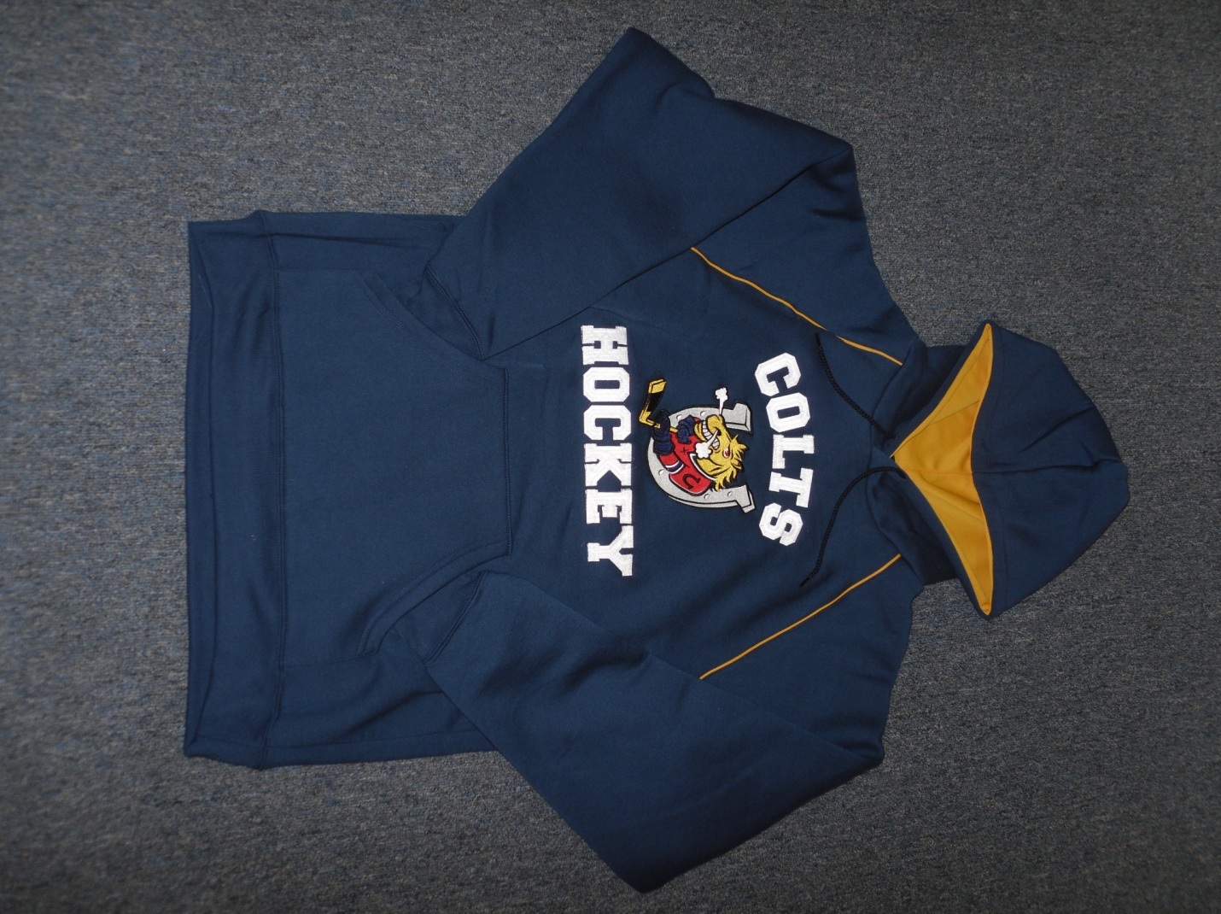
Sizes available: Adult M, L and XL

