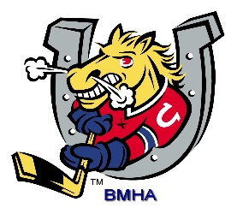
Barrie Minor Hockey Association
Annual General Meeting
When: Sunday September 20, 2020 9:00am (Virtual via Zoom)
Registration must be submitted by 5:00pm on Thursday September 17.
Registration form
The following Directors positions will be up for election:
- Director of HL Select
- Director of Rep Sr
- Director of Initiation Program
- Director of Finance
- Director of HL Senior
- Director of Ice
- Director of Sponsorship
Nomination Forms can be found by following the link below.
BMHA Nomination Form
Nomination Forms must be submitted by September 6, 2020
Any Constitutional Amendments must be submitted by September 6, 2020.

