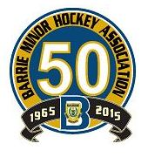
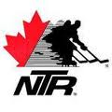
Save This Date:

Sat. Aug. 22, 2015

GENTLY USED HOCKEY EQUIPMENT SALE & BBQ
at NATIONAL TRAINING RINKS (NTR) from 8:00am to 12:00pm

- Items accepted – hockey skates, sticks, hockey pants, shin pads, elbow pads, shoulder pads, gloves, neck guards, blockers, trappers, chest protectors, goalie pads, hockey shirts and socks

  - Items NOT Accepted – Helmets and jocks
DONATIONS CAN BE DROPPED OFF:

NOW from 9am - 5pm @ Barrie Minor Hockey Association
93 Bell Farm Rd, Suite 120B
OR

Thurs., Aug. 20TH and Fri., Aug. 21TH from 6pm - 8pm @ NTR

120 Big Bay Point Rd.

All proceeds donated to Jamie Reid Endowment Fund, Canadian Tire Jumpstart

FOR ADDITIONAL INFORMATION OR PRIZE DONATION, CONTACT
LISA FOX @ 705 715-7999 OR lisa@lisafox.ca

COMMUNITY-WIDE EVENT - EVERYONE IS WELCOME!
