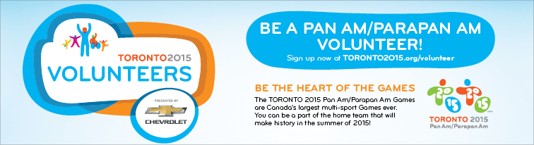

Toronto 2015 Pan Am / Parapan Am Games – The Drive for 20,000+ Volunteers

Thinking about how to fill the long summer days in 2015? Not yet? You should be!

The summer of 2015 will see the largest international multi-sport Games ever hosted by our great nation right here in Toronto and the Greater Golden Horseshoe region, rather than watch it on television or from the stands, YOU could be a part of the action!

Why should you volunteer for the TORONTO 2015 Pan Am/Parapan Am Games?

We can give you more than 20,000 reasons why…but how about getting up close to athletes, officials and international sport associations! There’s also exclusive promotions, events, and discounts on tickets and merchandise.

Don’t delay – volunteer interviews have begun! Applicants will begin receiving online video interviews this summer, and offer letters will start being sent this fall.

Apply now and be one of the first to tell the world what you will be doing in the summer of 2015!
To help us recognize members of the sports community in the application system, please:
• Complete the sport experience section of the application
• Use the volunteer code VOLSPT (This reference code will only be active until July 31st, 2014)

Apply now at www.toronto2015.org/volunteer

If you have questions about your volunteer application, please contact the TORONTO 2015 Volunteer Contact Centre (1-855-388-2015 / TTY: 1-800-465-4653).

Learn more about the Games at TORONTO2015.org.

