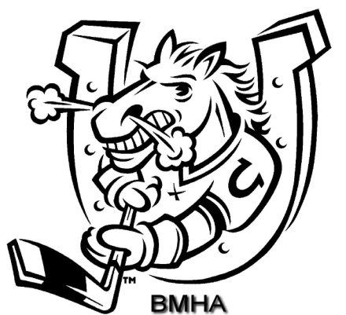

BARRIE MINOR HOCKEY ASSOCIATION

SPONSORSHIP

PHONE 705-734-1121

FAX 705-734-9632

Email : bmha_admin@bellnet.ca

93 Bell Farm Road, Unit 120B
Barrie, Ontario
L4M 5G1

2017-2018

TABLE OF CONTENTS

Mission Statement & History of BMHA 3

Current BMHA Initiatives 4-5
Sponsorship Program 6
BMHA Program Outline 7
Sponsorship Application 8

Mission Statement

To develop, encourage and maximize inclusive hockey opportunities for all players and volunteers to participate in the pursuit of excellence.

Team play Hard work Volunteerism

Values

1. to encourage community spirit, fellowship, team play and friendly rivalries
2. to promote determination, hard work and positive life skills
3. to foster community volunteerism

History, Today, and Tomorrow

Established in 1966

- BMHA is the only league in Barrie sanctioned by Hockey Canada and insured through Hockey Canada

- Not for profit organization

- Coaches, Assistant Coaches and Trainers require certification

- BMHA adheres to all Hockey Canada Rules & Regulations

- All home games are played within the City of Barrie

- We have just over 2,200 skaters and over 750 volunteers within the organization

- 104 house league teams

- 11 Select teams

- 31 rep teams

- Special needs division

- Squirt division and player development programs

Current BMHA Initiatives

- Team donations to local charities
- Colts Intermission Program
Minor Tyke participating in scrimmages
- Tournaments: Canadian Tire A/AE Classic
Glenn Bellerby Moose Winooski AA
Pro Oil Changers House League Select
- Bench Staff Appreciation Night
- IP Festival – Myte program
- BMHA Equipment Swap
- Day of Champions
- Fun Day
- BMHA Special Needs division
- Coach Development Clinics
- Player Development Clinics
- Development Camps

BARRIE MINOR HOCKEY ASSOCIATION

DEVELOPMENT PROGRAM

Age # Teams Division Rep HL Select
House
League

3 yrs 1 Squirts

4 yrs 4 Myte NA NA

5/6 yrs 14 Minor Tyke NA NA

7 yrs 8 Tyke Jr Colts 1
(2 teams)

8 yrs 8 Novice A, AA 1

9 yrs 10 Minor Atom AE, A, AA 1

10 yrs 10 Atom AE, A, AA 2

11 yrs 8 Minor Peewee AE, A, AA 2
12 yrs 10 Peewee AE, A (2), AA 2

13 yrs 10 Minor Bantam AE (2), A, AA 1
14 yrs 8 Bantam AE (2), A, AA 1

15 yrs 6 Minor Midget AE, A, AA 1

16/17 yrs 6 Midget AE, A, AA 1

Why Sponsor?
The Barrie Minor Hockey Association attempts to assist each and every child ages 3 – 17 years in the City of Barrie to play hockey. We also have a Special Needs division to provide further accessibility to all Barrie children.

Your sponsorship is a very valuable piece of the fund raising budget. More importantly it gives the players on the team an identity as a TEAM. When sponsoring in the BMHA you know that your dollars are making a difference.
On behalf of all of the players, parents, and BMHA executives, thank you for your support!

Sponsorship Program

What cost is involved to sponsor?

There are four levels of team Sponsorship in the BMHA.
House League $550.00
Rep “AE” $850.00
Rep “A” $950.00
Rep “AA” $1000.00
Jr Colts $750.00

As a sponsor, if you wish to provide a team with additional financial
support over and above your sponsorship, this is strictly your decision.

What will I receive as a team sponsor?

The BMHA will ensure that:
- Your company name is on the back of your team’s jersey
- Your company name, logo and weblink will be featured on our BMHA website at www.barrieminorhockey.net.
- Your company name, logo and weblink will be featured on the sponsored BMHA team webpage
- You will receive a sponsorship plaque with a picture of your team
- Your sponsored team will be mentioned in various media
(local radio/newspapers)
- You will be recognized for your sponsorship in our annual yearbook
- You will have the pleasure of knowing your company has made a difference to the children and youth of our community
- You are welcome to place your company literature or business cards in our “Sponsor’s Corner” at the BMHA Office
- Team sponsors are invited to promote business specials, information, promotions etc. on the BMHA website.

What if I have special team requests?

We attempt to work with our sponsors at all times. You are welcome to indicate your preference. All sponsorship commitment will be done on a first come, first serve basis. PREFERENCE GIVEN TO THE SPONSOR FROM THE PREVIOUS YEAR.

SPONSORSHIP REQUEST FORM
2017/18 SEASON

House League ____ $550.00
Rep League “AE” ____ $850.00
Rep League “A” ____ $950.00
Rep League “AA” ____ $1000.00

Preferred Division: ____________________________

Contact Person: ____________________________

Phone Number: ____________________________

Address and Postal Code: ___________________________

Sponsor Name: ____________________________

Email address: ____________________________

Thank you again for your support,

BMHA Sponsorship Director – Tim Kraft

Once you have made your choice of sponsorship, please fill out the request form and mail with your cheque payable to:
Barrie Minor Hockey Association
93 Bell Farm Rd. Suite 120
Barrie, Ontario
L4M 5G1

